# Research Questionnaire

Name and E-mail are *optional* it may be necessary for us to get in touch with you in the future for further research on this subject. We really appreciate your cooperation.

Name (optional):

E-mail (optional):

Educational institution/Work place:

Course/Year:

Please number the following languages by *preference,* (lowest is most preferred). Also, please keep in mind you don’t need to fill all of them in.

|  |  |
| --- | --- |
| __ ASP.NET | __ Lisp |
| __ C | __ Matlab |
| __ C++ | __ Objective-C |
| __ C# | __ Perl |
| __ Clojure | __ PHP |
| __ F# | __ Python |
| __ Go | __ Ruby |
| __ Haskell | __ Scala |
| __ Java | __ Swift |
| __ Javascript | __ Visual Basic |

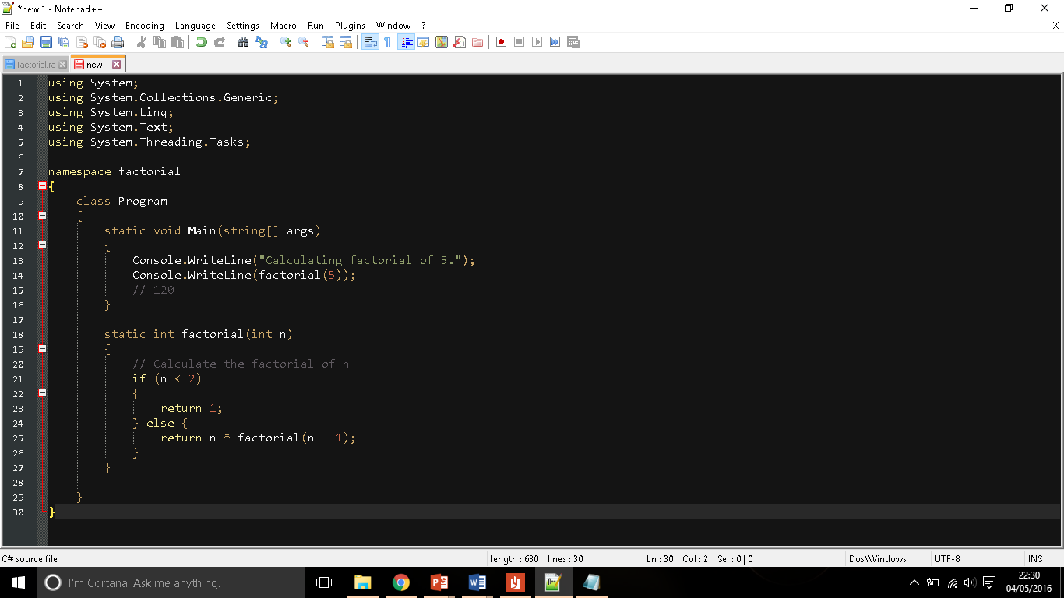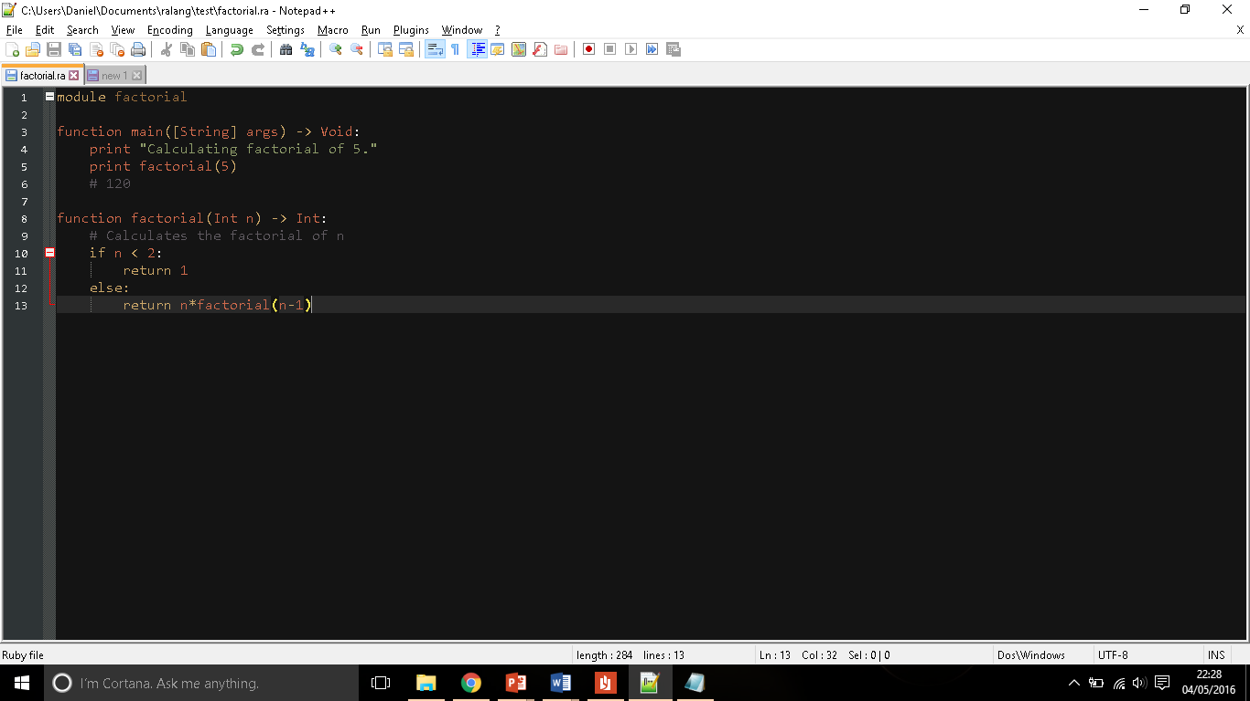Please study the following program below. Try to understand the control flow of Ralang, and identify their similarities and differences between the two examples.

Figure 2. Program written in C#

Figure 1. Program written in Ralang

Please use the table below to give us some feedback:

|  |  |  |  |  |  |
| --- | --- | --- | --- | --- | --- |
|  | **Strongly Agree** | **Agree** | **No opinion** | **Disagree** | **Strongly Disagree** |
| *1. I have more than one-year programming experience* |  |  |  |  |  |
| *2. Programming is challenging to learn* |  |  |  |  |  |
| *3. Ralang appears to be readable and easy to follow* |  |  |  |  |  |
| *4. There are a lot of similarities between both languages* |  |  |  |  |  |
| *5. Ralang could be used as an educational programming language* |  |  |  |  |  |
| *6. C# syntax is very neat and easy to understand* |  |  |  |  |  |
| *7. Flow of control seems to be very different in both languages* |  |  |  |  |  |
| *8. Ralang’s syntax and control flow are not made very clear* |  |  |  |  |  |
| *9. I don’t want to hear about Ralang ever again!* |  |  |  |  |  |
| *10. I would be interested in learning more about Ralang* |  |  |  |  |  |

Please use the following section to let us know how you feel about Ralang project: